**\*\*\*\*\*\*\*\*\*\*\*\*\*\*\*\*\*\*\*\*\*\*\*\*001-background.html\*\*\*\*\*\*\*\*\*\*\*\*\***

<!DOCTYPE html>

<html>

<head>

<meta http-equiv="Content-Type" content="text/html; charset=ISO-8859-1">

<title>Background Demo</title>

<link href="001-demo1.css" rel="stylesheet">

</head>

<body>

<div class="site-wrapper">

<div class="div1">div 1 background</div>

<div class="div2">div 2 background</div>

<div class="div3">div 3 background</div>

</div>

</body>

</html>

**\*\*\*\*\*\*\*\*\*\*\*\*\*\*\*\*\*\*\*\*\*001-demo1.css\*\*\*\*\*\*\*\*\*\*\*\*\*\*\*\*\*\*\*\*\*\*\*\***

@CHARSET "ISO-8859-1";

.site-wrapper {

margin-top: 20px;

margin-left: 20px;

height: 500px;

width: 800px;

background-color: lightgrey;

}

.div1 {

height: 150px;

width: 800px;

background-color: red;

}

.div2 {

height: 150px;

width: 800px;

background-color: blue;

}

.div3 {

height: 150px;

width: 800px;

background-color: green;

}

******************Output************

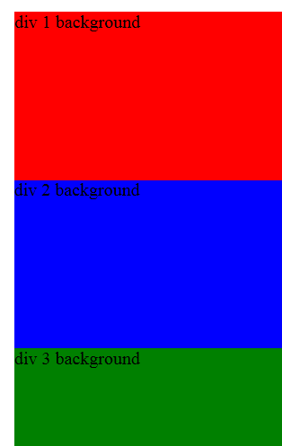

**\*\*\*\*\*\*\*\*\*\*\*\*\*\*\*\*\*\*\*\*002-background_image.html\*\*\*\*\*\*\*\*\*\*\*\*\*\*\*\*\*\*\*\*\*\*\*\*\*\***

<!DOCTYPE html>

<html>

<head>

<meta http-equiv="Content-Type" content="text/html; charset=ISO-8859-1">

<title>Demo - Background image</title>

<link href="002-demo2.css" rel="stylesheet">

</head>

<body>

<div class="site-wrapper">This is how background looks like!!!!</div>

</body>

</html>

**\*\*\*\*\*\*\*\*\*\*\*\*\*\*\*002-demo2.css\*\*\*\*\*\*\*\*\*\*\*\*\*\*\*\*\*\*\*\*\*\*\*\*\*\*\*\***

@CHARSET "ISO-8859-1";

.site-wrapper

{

margin-top:20px;

margin-left:20px;

height:500px;

width: 800px;

background-color: lightgrey;

background-image: url("images/flower.PNG");

/* background-repeat: no-repeat;

background-repeat: repeat-x;

background-repeat: repeat-y*/

background-repeat: no-repeat;

/* background-position: top right;

background-position: bottom right;

background-position: bottom left;*/

}

**\*\*\*\*\*\*\*\*\*\*\*\*\*\*\*output\*\*\*\*\*\*\*\*\*\*\***

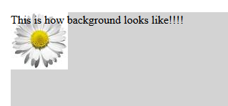

**\*\*\*\*\*\*\*\*\*\*\*\*\*\*\*\*\*\*\*\*\*\*\*\*\*003-background2.html\*\*\*\*\*\*\*\*\*\*\*\*\*\*\*\*\***

<!DOCTYPE html>

<html>

<head>

<meta http-equiv="Content-Type" content="text/html; charset=ISO-8859-1">

<link href="003-demo4.css" rel="stylesheet">

<title>Background demo 2</title>

</head>

<body>

<h1>Demonstrating Background</h1>

<div class="site-wrapper"></div>

</body>

</html>

**\*\*\*\*\*\*\*\*\*\*\*\*\*\*\*\*\*003-demo4.css\*\*\*\*\*\*\*\*\*\*\*\*\*\*\*\*\*\*\*\*\*\*\*\*\*\*\***

@CHARSET "ISO-8859-1";

h1

{

margin-left:10px;

width:950px;

background-color: powderblue;

colour:#FF00FF;

font-family: calibri;

}

.site-wrapper

{

margin-left:10px;

height:480px;

width:950px;

border: solid black;

background-image: url("images/flower.PNG");

background-repeat: space repeat;

}

**\*\*\*\*\*\*\*\*\*\*\*\*\*\*\*\*\*\*\*Output\*\*\*\*\*\*\*\*\*\*\*\*\*\*\*\*\*\*\*\*\***

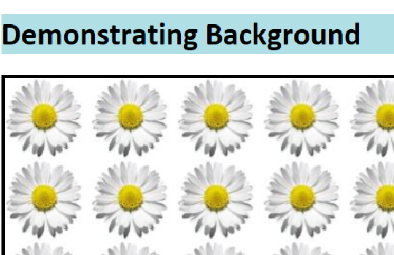

**\*\*\*\*\*\*\*\*\*\*\*\*\*\*\*\*\*\*\*\*\*\*\*\*\*\*\*004-color.css\*\*\*\*\*\*\*\*\*\*\*\*\*\*\*\*\*\*\*\*\*\*\*\*\*\*\*\*\***

@CHARSET "ISO-8859-1";

.site-wrapper

{

margin-top:30px;

margin-left:50px;

height:600px;

width:900px;

border:solid 1px;

border-color:black;

border-radius:25px;

}

h1

{

color:#780000;

text-align: center;

}

.top-left

{

margin-top:10px;

margin-left:10px;

height:220px;

width:420px;

border:solid 1px;

border-color:grey;

border-radius:25px;

float:left;

background-color:rgb(0,255,0);

text-align: center;

}

.top-right

{

margin-top:10px;

margin-left:10px;

margin-right:10px;

height:220px;

width:420px;

border:solid 1px;

border-color:grey;

border-radius:25px;

float:right;

background-color:rgba(255,0,0,0.4);

text-align: center;

}

.bot-left

{

margin-top:10px;

margin-left:10px;

height:220px;

width:420px;

border:solid 1px;

border-color:grey;

border-radius:25px;

float:left;

text-align: center;

background-color:hsl(120,65%,75%);

}

.bot-right

{

margin-top:10px;

margin-left:10px;

margin-right:10px;

height:220px;

width:420px;

border:solid 1px;

border-color:grey;

border-radius:25px;

float:right;

background-color :hsla(120,65%,75%,0.3);

text-align: center;

}

h1#footer

{

color:currentColor;

}

**\*\*\*\*\*\*\*\*\*\*\*\*\*\*\*\*\*\*\*\*004-demoColor.html\*\*\*\*\*\*\*\*\*\*\*\*\*\***

<!DOCTYPE html>

<html>

<head>

<meta http-equiv="Content-Type" content="text/html; charset=ISO-8859-1">

<link href="004-color.css" rel="stylesheet"/>

<title>Demo Color</title>

</head>

<body>

<div class="site-wrapper">

<h1>Illustrating CSS color</h1>

<div class="top-left">

Color Set with rgb()

</div>

<div class="top-right">

Color Set with rgba()

</div>

<div class="bot-left">

Color Set with hsl()

</div>

<div class="bot-right">

Color Set with hsla()

</div>

<h1 id="footer">Here how we use currentColor</h1>

</div>

</body></html>

**\*\*\*\*\*\*\*\*\*\*\*\*\*\*\*\*\*\*\*output\*\*\*\*\*\*\*\*\*\*\*\*\*\*\*\*\*\*\*\*\***

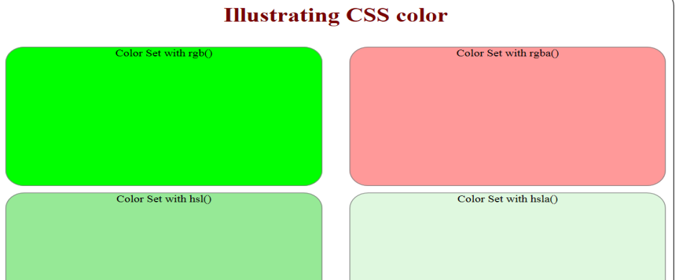

**\*\*\*\*\*\*\*\*\*\*\*\*\*\*005-gradient.css\*\*\*\*\*\*\*\*\*\*\*\*\*\*\*\*\*\*\*\*\*\*\*\*\*\*\***

@CHARSET "ISO-8859-1";

.site-wrapper

{

margin-top:30px;

margin-left:50px;

height:600px;

width:900px;

border:solid 23px;

border-color:black;

border-radius:25px;

}

h1

{ color:#600000;

background:-webkit-gradient(linear, left top, right top,

color-stop(0%,#f0b7a1),

color-stop(50%,#8c3310),

color-stop(51%,#752201),

color-stop(100%,#bf6e4e));

text-align: center;

}

.top

{

margin-top:10px;

margin-left:10px;

height:220px;

width:880px;

border:solid 1px;

border-color:grey;

border-radius:25px;

float:left;

background: -webkit-gradient(linear, left top, left bottom, color-stop(0%,#1e5799), color-stop(50%,#2989d8), color-stop(51%,#207cca), color-stop(100%,#7db9e8));

text-align: center;

}

.down

{

margin-top:10px;

margin-left:10px;

height:220px;

width:880px;

border:solid 1px;

border-color:grey;

border-radius:25px;

float:left;

text-align: center;

background: -webkit-gradient(linear, left top, left bottom, color-stop(0%,#f85032), color-stop(50%,#f16f5c), color-stop(51%,#f6290c), color-stop(71%,#f02f17), color-stop(100%,#e73827));

}

**\*\*\*\*\*\*\*\*\*\*\*\*\*\*\*005-demoGradient.html\*\*\*\*\*\*\*\*\*\*\*\*\*\*\*\*\*\*\*\*\*\*\*\***

<!DOCTYPE html>

<html>

<head>

<meta http-equiv="Content-Type" content="text/html; charset=ISO-8859-1">

<link href="005-gradient.css" rel="stylesheet" />

<title>Gradient Demo</title>

</head>

<body>

<div class="site-wrapper">

<h1>Illustrating CSS color Gradient</h1>

<div class="top"></div>

<div class="down"></div>

</div>

</body>

</html>

**\*\*\*\*\*\*\*\*\*\*\*\*\*\*\*\*\*\*\*\*\*\*\*\*\*\*\*Output\*\*\*\*\*\*\*\*\*\*\*\*\*\*\*\*\*\*\*\*\*\***

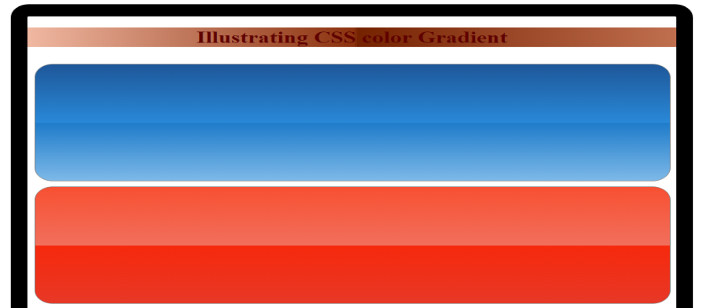

**\*\*\*\*\*\*\*\*\*\*\*\*\*\*\*\*\*\*\*\*\*006-multi_image.css\*\*\*\*\*\*\*\*\*\*\*\*\*\*\*\*\*\*\*\*\*\*\*\*\*\*\*\*\*\***

@CHARSET "ISO-8859-1";

@CHARSET "ISO-8859-1";

div

{

top:30px;

width:900px;

height:500px;

background-color: cyan;

background: url("images/image2.jpg")

left

top

no-repeat,

url("images/image1.jpg")

right

bottom

no-repeat;

background-orogin:content-box;

}

**\*\*\*\*\*\*\*\*\*\*\*\*\*\*\*\*\*\*\*006-multiple_image_background.html\*\*\*\*\*\*\***

<!DOCTYPE html>

<html>

<head>

<meta http-equiv="Content-Type" content="text/html; charset=ISO-8859-1">

<link href="006-multi_image.css" rel="stylesheet">

<title>Multiple image background</title>

</head>

<body>

<h1>Multiple Image Background</h1>

<div>

</div>

</body>

</html>

**\*\*\*\*\*\*\*\*\*\*\*\*\*\*\*\*\*\*\*\*\*\*\*\*output\*\*\*\*\*\*\*\*\*\*\*\*\*\*\*\*\*\*\*\*\*\*\***



**\*\*\*\*\*\*\*\*\*\*\*\*\*\*\*\*Border\*\*\*\*\*\*\*\*\*\*\*\*\*\*\*\*\*\*\*\*\*\*\*\*\*\*\*\*\*\*\*\*\*\*\*\*\*\*\*\*\***

**\*\*\*\*\*\*\*\*\*\*\*\*\*\*\*010-demo1\*\*\*\*\*\*\*\*\*\*\*\*\*\*\*\*\*\*\*\*\*\*\*\*\*\*\*\*\*\*\*\*\*\*\*\***

@CHARSET "ISO-8859-1";

.d1 {

border-style: dotted;

border-width: 15px;

border-color: red;

}

.d2 {

border-style: dashed;

border-width: 5px;

border-color: rgb(0, 255, 0);

}

.d3 {

border-style: solid;

border-width: 5px;

border-color: #0000ff;

}

.d4 {

border-top-style: dotted;

border-right-style: dotted;

border-bottom-style: dashed;

border-left-style: solid;

border-top-color: #ff0000;

border-right-color: #00ff00;

border-bottom-color: #0000ff;

border-left-color: #0f0f0f;

}

**\*\*\*\*\*\*\*\*\*\*\*\*\*\*\*\*\*\*\*\*\*.010-demoBorder.html\*\*\*\*\*\*\*\*\*\*\*\*\*\*\*\*\*\*\*\*\*\*\*\*\*\*\*\*\***

<!DOCTYPE html>

<html>

<head>

<meta http-equiv="Content-Type" content="text/html; charset=ISO-8859-1">

<title>Border Demo</title>

<link href="010-demo1.css" rel="stylesheet">

</head>

<body>

<h1>Border Demo</h1>

<div class="d1">

Dotted Border

</div>

<br/>

<div class="d2">

Dashed Border

</div>

<br/>

<div class="d3">

Solid Border

</div>

<br/>

<div class="d4">

Combining together

</div>

</body>

</html>

**\*\*\*\*\*\*\*\*\*\*\*\*\*\*\*\*\*\*\*\*\*output\*\*\*\*\*\*\*\*\*\*\*\*\*\*\*\*\*\*\*\*\*\*\*\*\*\*\*\*\*\*\*\*\*\*\*\*\*\*\*\*\*\*\*\*\*\*\*\***

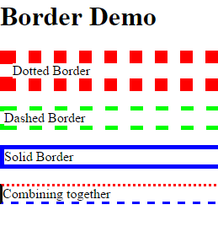

**\*\*\*\*\*\*\*\*\*\*\*\*\*\*\*\*\*\*\*\*011-demo2.css\*\*\*\*\*\*\*\*\*\*\*\*\*\*\*\*\*\*\*\*\*\*\*\*\*\*\*\*\*\*\***

@CHARSET "ISO-8859-1";

.d1 {

border-style: solid;

border-color: red;

padding: 10px, 40px;

background-color: lightgrey;

resize: both;

overflow: auto;

height: 50px;

width: 80px;

}

.d2 {

background-color: lightgrey;

border-style: solid;

border-color: red;

padding: 10, 20;

border-radius: 25px;

height: 50px;

width: 80px;

text-align: center;

}

.d3 {

background-color: lightgrey;

border-style: solid;

border-color: red;

box-shadow: 10px 10px 5px #888888;

height: 50px;

width: 80px;

}

.d4 {

height: 50px;

width: 80px;

border-image: url(images/flower.PNG) 30 30 round;

}

**\*\*\*\*\*\*\*\*\*\*\*\*\*\*\*\*\*\*\*\*\*\*\*.011-demoBorder_CSS 3.0.html\*\*\*\*\*\*\*\*\*\*\*\*\*\*\*\*\*\*\*\*\*\*\***

<!DOCTYPE html>

<html>

<head>

<meta http-equiv="Content-Type" content="text/html; charset=ISO-8859-1">

<title>Boder Demo2</title>

<link href="011-demo2.css" rel="stylesheet">

</head>

<body>

<h1>Border Demo</h1>

<div class="d1">

Resizable Border

</div>

<br/>

<div class="d2">

Rounded Border

</div>

<br/>

<div class="d3">

Box Shadow

</div>

<br/>

<div class="d4">

Image Border

</div>

<br/>

<div>

<img src="images/flower.PNG"/>

</div>

</body>

</html>

**\*\*\*\*\*\*\*\*\*\*\*\*\*\*\*\*\*\*output\*\*\*\*\*\*\*\*\*\*\*\*\*\*\*\*\*\*\*\*\*\*\*\*\*\*\*\*\*\*\*\*\*\*\*\*\*\*\***

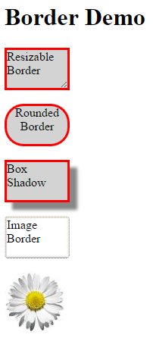

**\*\*\*\*\*\*\*\*\*\*\*\*\*\*Extra*************Translate.html\*\*\*\*\*\*\*\*\*\*\*\*\*\*\*\*\*\*\*\*\*\*\*\***

<!DOCTYPE html>

<html>

<head>

<!---ms-transform: translate(50px,100px); /* IE 9 */

transform: translate(50px,100px); /* Standard syntax */-->

<style>

div {

width: 300px;

height: 100px;

background-color: yellow;

border: 1px solid black;

-webkit-transform: translate(450px,300px); /* Safari */

}

</style>

</head>

<body>

<div>

The translate() method moves an element from its current position. This div element is moved 50 pixels to the right, and 100 pixels down from its current position.

</div>

</body>

</html>

**\*\*\*\*\*\*\*\*\*\*\*\*\*\*\*rotate.html\*\*\*\*\*\*\*\*\*\*\*\*\*\*\*\*\*\*\*\*\*\*\*\*\*\*\***

<!DOCTYPE html>

<html>

<head>

<style>

div {

width: 300px;

height: 100px;

background-color: yellow;

border: 1px solid black;

}

div#myDiv {

-webkit-transform: rotate(20deg); /* Safari */

}

</style>

</head>

<body>

<div>

This a normal div element.

</div>

<div id="myDiv">

The rotate() method rotates an element clockwise or counter-clockwise. This div element is rotated clockwise 20 degrees.

</div>

</body>

</html>

**\*\*\*\*\*\*\*\*\*\*\*\*\*\*\*\*\*\*\*\*\*scale.html\*\*\*\*\*\*\*\*\*\*\*\*\*\*\*\*\*\*\*\***

<!DOCTYPE html>

<html>

<head>

<style>

div {

margin: 150px;

width: 150px;

height: 100px;

background-color: yellow;

border: 1px solid black;

border: 1px solid black;

}

div.divId {

margin: 150px;

width: 150px;

height: 100px;

background-color: yellow;

border: 1px solid black;

border: 1px solid black;

-ms-transform: scale(2,3); /* IE 9 */

-webkit-transform: scale(2,3); /* Safari */

transform: scale(2,3); /* Standard syntax */

}

</style>

</head>

<body>

() method increases or decreases the size of an element.</p>

<div>

This div element is two times of its original width, and three times of its original height.

</div>

<div class="divId">

This div element is two times of its original width, and three times of its original height.

</div>

</body>

</html>

**\*\*\*\*\*\*\*\*\*\*\*\*\*\*\*\*\*\*\*output\*\*\*\*\*\*\*\*\*\*\*\*\*\*\*\*\*\***

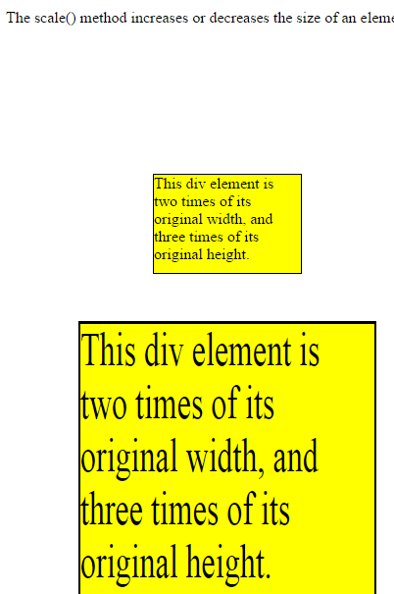

**\*\*\*\*\*\*\*\*\*\*\*\*\*\*\*\*\*skew.html\*\*\*\*\*\*\*\*\*\*\*\*\*\*\*\*\***

<!DOCTYPE html>

<html>

<head>

<style>

div {

width: 300px;

height: 100px;

background-color: yellow;

border: 1px solid black;

}

div#myDiv {

-ms-transform: skewX(20deg); /* IE 9 */

-webkit-transform: skewX(20deg); /* Safari */

transform: skewX(20deg); /* Standard syntax */

}

</style>

</head>

<body>

<p>The skewX() method skews an element along the X-axis by the given angle.</p>

<div>

This a normal div element.

</div>

<div id="myDiv">

This div element is skewed 20 degrees along the X-axis.

</div>

</body>

</html>

**\*\*\*\*\*\*\*\*\*\*\*\*\*\*\*\*output.html\*\*\*\*\*\*\*\*\*\*\*\*\*\*\*\*\*\*\*\*\*\*\*\*\*\*\*\*\*\*\*\*\*\***

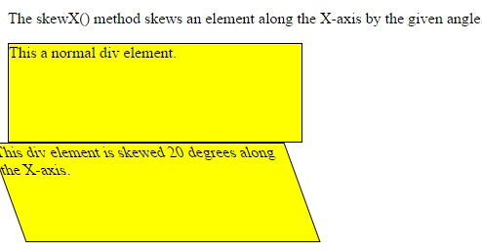

**\*\*\*\*\*\*\*\*\*\*\*\*\*\*\*\*\*\*\*\*\*\*\*\*\*\*Animation\*\*\*\*\*\*\*\*\*\*\*\*\*\*\*\*\*\*\*\*\*\*\*\*\*\*\*\*\*\*\*\***

**\*\*\*\*\*\*\*\*\*\*\*\*\*021-demo0.css\*\*\*\*\*\*\*\*\*\*\*\*\*\*\*\*\*\*\*\*\***

@CHARSET "ISO-8859-1";

@-webkit-keyframes aniEx1

{

0% {background: red;}

25% {background: yellow;}

50% {background: blue;}

100% {background: green;}

}

.d1

{

border-style:solid;

border-color:black;

border-radius:30px;

height:200px;

width:200px;

text-align:center;

-webkit-animation: aniEx1 5s;

-webkit-animation-play-state: running;

-webkit-animation-iteration-count: 2;

}

**\*\*\*\*\*\*\*\*\*\*\*\*\*\*\*\*\*\*\*\*\*\*021-Animation0.html\*\*\*\*\*\*\*\*\*\*\*\***

<!DOCTYPE html>

<html class="no-js">

<head>

<meta http-equiv="Content-Type" content="text/html; charset=ISO-8859-1">

<title>Animation Demo</title>

<link href="021-demo0.css" rel="stylesheet">

<script src="modernizr-latest.js"></script>

</head>

<body>

<h1>Animation Demo - 1</h1>

<div class="content">

<div class="d1">I am Animated:)</div>

</div>

</body>

</html>

**\*\*\*\*\*\*\*\*\*\*\*\*\*\*\*\*\*\*\*\*\*\*\*\*output\*\*\*\*\*\*\*\*\*\*\*\*\*\*\*\*\*\*\*\*\*\*\*\*\*\*\*\*\*\*\*\*\*\***

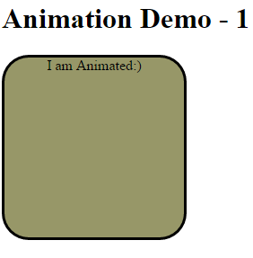

**\*\*\*\*\*\*\*\*\*\*\*\*\*\*\*\*\*\*\*\*\*022-demo1.css\*\*\*\*\*\*\*\*\*\*\*\*\*\*\*\*\*\*\*\*\*\*\*\*\*\*\*\***

@CHARSET "ISO-8859-1";

.content

{

height:1000px;

width:950px;

border-style: solid;

border-color: black;

}

.d2

{

margin-top:200px;

margin-left:200px;

border-style: solid;

border-color: red;

height:300px;

width:300px;

top:50px;

background-color: lightgrey;

size: 200px;

border-radius:25px;

}

.d2_sub

{

position:absolute;

margin-top:20px;

margin-left:20px;

align:center;

border-style: solid;

border-color: red;

height:250px;

width:250px;

border-radius:25px;

background-color: powderblue;

text-align: center;

-webkit-animation: third_ani 5s;

-webkit-animation-play-state: running;

-webkit-animation-iteration-count: 2;

}

/*Change the background color*/

@-webkit-keyframes first_ani /* Safari and Chrome */

{

from {background: powderblue;}

to {background: yellow;}

}

/*Change the background color when the animation is 25%, 50%

and again when the animation is 100% complete:*/

@-webkit-keyframes second_ani /* Safari and Chrome */

{

0% {background: red;}

25% {background: yellow;}

50% {background: blue;}

100% {background: green;}

}

@-webkit-keyframes third_ani /* Safari and Chrome */

{

0% {background: red; left:0px;}

25% {background: yellow; left:200px;}

50% {background: blue; left:200px;}

75% {background: green; left:0px; }

100% {background: red; left:0px;}

}

@-webkit-keyframes fourth_ani /* Safari and Chrome */

{

0% {background: red; left:0px; top:0px;}

25% {background: yellow; left:200px; top:0px;}

50% {background: blue; left:200px; top:200px;}

75% {background: green; left:0px; top:200px;}

100% {background: red; left:0px; top:0px;}

}

**\*\*\*\*\*\*\*\*\*\*\*\*\*\*\*022-Animation1.html\*\*\*\*\*\*\*\*\*\*\*\*\*\*\*\*\*\*\*\*\*\***

<!DOCTYPE html>

<html>

<head>

<meta http-equiv="Content-Type" content="text/html; charset=ISO-8859-1">

<title>Animation Demo1</title>

<link href="022-demo1.css" rel="stylesheet">

</head>

<body>

<h1>Animation Demo</h1>

<div class="content">

<div class="d2">

<div class="d2_sub">I am Animated:)</div>

</div>

</div>

</body>

</html>

**\*\*\*\*\*\*\*\*\*\*\*\*\*\*\*\*\*\*\*\*\*\*\*\*\*\*\*\*\*\*\*\*\*\*\*\*\*\*\*\*\*\*\*\*\*\*\*\*\*\*\*\*23\*\*\*\*\*\*\*\*\*\*\*\*\*\*\***

**\*\*\*\*\*\*\*\*\*\*\*\*\*\*\*\*024-demo2.css\*\*\*\*\*\*\*\*\*\*\*\*\*\*\*\*\*\*\*\*\*\*\*\*\*\*\*\*\*\*\*\*\***

@CHARSET "ISO-8859-1";

.content

{

height:1000px;

width:950px;

border-style: solid;

border-color: black;

}

.d1

{

margin-top:20px;

margin-left:20px;

border-style: solid;

border-color: red;

height:300px;

width:300px;

top:50px;

background-color: lightgrey;

size: 200px;

}

.d1_sub

{

position:absolute;

margin-top:20px;

margin-left:20px;

align:center;

border-style: solid;

border-color: red;

height:250px;

width:250px;

}

.d2

{

margin-top:20px;

margin-left:20px;

border-style: solid;

border-color: red;

height:300px;

width:300px;

top:50px;

background-color: lightgrey;

size: 200px;

}

.d2_sub

{

-webkit-transition-duration:1s;

margin-top:20px;

margin-left:20px;

align:center;

text-align:center;

border-style: solid;

border-color: red;

height:250px;

width:250px;

background-color: powderblue;

border-radius:25px;

}

.d2_sub:hover

{

-webkit-transform:rotate(360deg);

}

**\*\*\*\*\*\*\*\*\*\*\*\*\*\*\*\*024-transition.html\*\*\*\*\*\*\*\*\*\*\*\*\*\*\*\*\*\*\*\*\*\*\*\*\*\*\*\***

<!DOCTYPE html>

<html>

<head>

<meta http-equiv="Content-Type" content="text/html; charset=ISO-8859-1">

<link href="024-demo2.css" rel="stylesheet">

<title>Insert title here</title>

</head>

<body>

<h1>Transition Demo</h1>

<div class="content">

<div class="d1">

<div class="d1_sub">I am not CHANGED!!</div>

</div>

<br />

<br />

<div class="d2">

<div class="d2_sub">I am Changing..:)</div>

</div>

</div>

</body>

</html>

\*\*\*\*\*\*\*\*\*\*\*\*\*\*\*\*\*\*\*\*\*\*\***output\*\*\*\*\*\*\*\*\*\*\*\*\*\*\*\*\*\*\*\*\*\*\*\*\*\***

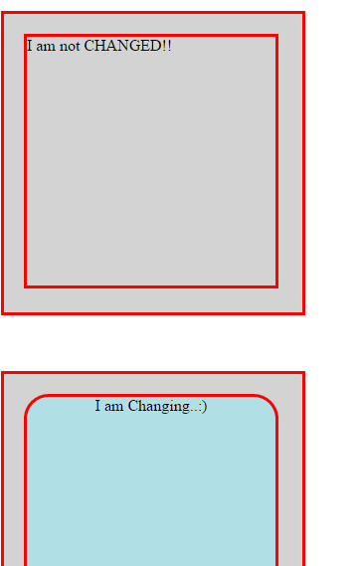

**\*\*\*\*\*\*\*\*\*\*\*\*\*\*\*\*\*\*\*\*\*\*024-transition.html\*\*\*\*\*\*\*\*\*\*\*\*\*\*\*\***

<!DOCTYPE html>

<html>

<head>

<style>

div {

width: 100px;

height: 100px;

background: red;

-webkit-transition: width 2s; /* For Safari 3.1 to 6.0 */

transition: width 2s;

}

div:hover {

width: 300px;

}

</style>

</head>

<body>

<p><b>Note:</b> This example does not work in Internet Explorer 9 and earlier versions.</p>

<div></div>

<p>Hover over the div element above, to see the transition effect.</p>

</body>

</html>

**\*\*\*\*\*\*\*\*\*\*\*\*\*\*\*\*\*\*\*\*output\*\*\*\*\*\*\*\*\*\*\*\*\*\*\*\*\*\*\*\*\*\*\*\*\***

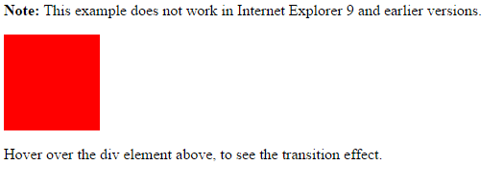

**\*\*\*\*\*\*\*\*\*\*\*\*\*\*\*\*\*\*\*\*Thank You\*\*\*\*\*\*\*\*\*\*\*\*\*\*\*\*\*\*\*\*\*\*\*\*\*\*\*\*\*\*\*\*\*\*\*\*\*\*\*\*\*\*\*\***